The City  Mouse
and the Country  Mouse

A little mouse lives in the country. He invites a little Mouse from the city to visit him. The little City Mouse sits to a dinner  and he sees that the Country Mouse has only barley 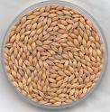 and grain 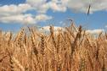.

He said, you don´t live well. Come to see how I live! I have fine things to eat 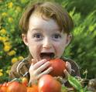 every day and how nice is the city. The little Country Mouse is

happy and goes to the city to visit his friend.
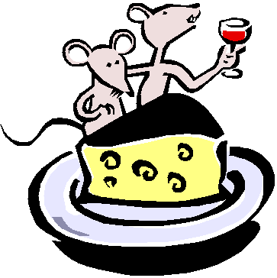
The 1st place they go is the kitchen cupboard 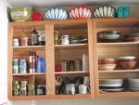 in the house.

There is a big paper bag of brown sugar. The little City Mouse invites his friend
to eat.
The two little mice eat and eat and the Country Mouse sais how nice it is and how lucky the City Mouse is. Suddenly the door 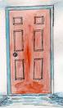 opens and the cook 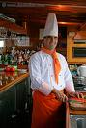 comes in. "Run!" sais the City Mouse. And they run and run to the hole 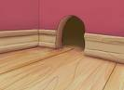 and the little Country Mouse shakes.

The 2nd place they go is the top shelf with a big jar of dried prunes.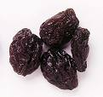 „This is better than the brown sugar“ sais the Country

Mouse. The little Country Mouse likes it but suddenly the cat comes MIAOUW!

"What is it?" sais the Country Mouse. The City Mouse sais "Ssssh!" and runs fast to the hole. 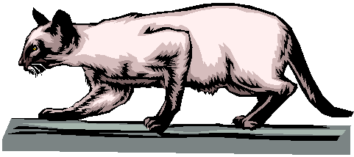

"This is terrible," sais the little Country Mouse.

The 3rd place they go is the cellar 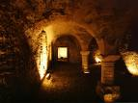.

The City Mouse goes with the little friend to the cellar to a big cupboard with shelves. On the shelves there are jars of butter 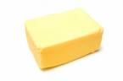, and cheese 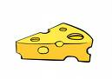and sausages 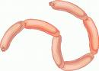. The little Country Mouse sees

a cheese and goes to eat it. "Stop! stop!" sais the City Mouse. "That is a trap!" 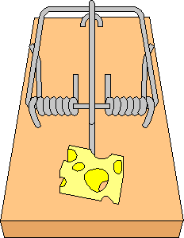 The little Country Mouse stopps and sais, "What is a trap?"

"This is a trap," sais the little City Mouse. You eat this cheese and something

comes down on your head and you are dead."

The little Country Mouse looks at the trap, and he looks at the cheese, and he

looks at the little City Mouse. "Excuse me," he sais, "I go home. I rather want

barley and grain in peace and comfort, than eat brown sugar, dried prunes and

cheese--and be frightened to death all the time!"
And so the little Country Mouse goes home and stays there forever. 

Dictionary - Slovníček

better than lepšie ako
come prísť
dead mŕtvy
head hlava
how ako
invite pozvať
lucky šťastný
jar džbán, pohár, fľaša
nice milý, pekný
only iba, len
peace pokoj
place miesto
rather want radšej chcem
run bežať
see vidieť
shake triasť sa
something niečo
suddenly zrazu
sugar cukor
terrible hrozný
then potom
top shelf horná polička
trap pasca
visit navštíviť, návšteva
...and be frightened to death all the time .... a byť vkuse vyľakaný na smrť
...stays there forever .... zostane tam navždy

